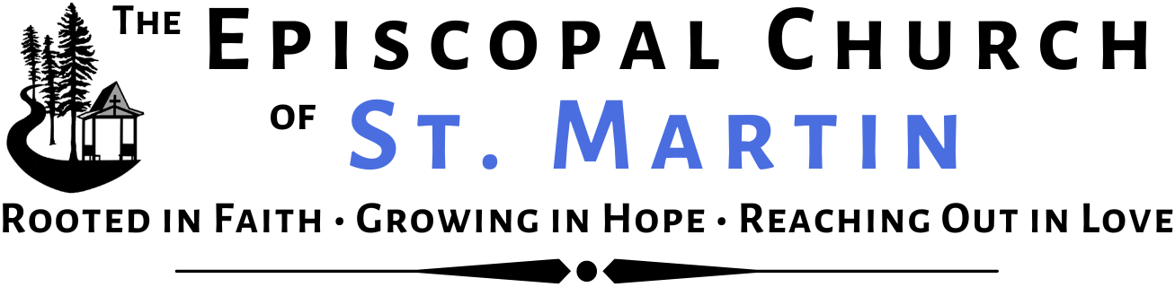
The Nineteenth Sunday after Pentecost and The Feast of St. Francis of Assisi
Holy Eucharist Rite II at 10am - Sunday, October 4, 2026

SERVICE NOTES: Welcome! We are glad you have joined us! We encourage you to sing and pray actively, as you are able. All of today’s music is printed in this bulletin. The congregation is invited to read the words in bold. Welcome! Bienvenidos!

PRELUDE “Partita on Almighty God of Majesty” F. Peeters

Please stand, as you are able. On page 9
OPENING HYMN H 400 “All creatures of our God and king” (Lasst uns freuen) verses 1, 4, 5, 7

OPENING ACCLAMATION
Presider This is the day the Creator has made.
People Let us rejoice and be glad in it.

COLLECT FOR PURITY The Presider says
Almighty God, to you all hearts are open, all desires known, and from you no secrets are hid: Cleanse the thoughts of our hearts by the inspiration of your Holy Spirit, that we may perfectly love you, and worthily magnify your holy Name; through Christ our Lord. Amen.

All may join in singing.
SONG OF PRAISE MHSO 131 “We are a part of all creation,” M. Haugen On page 10

COLLECT FOR THE FEAST OF ST. FRANCIS OF ASSISI
Presider The Creator be with you.
People And also with you.
Presider Let us pray. Most high, omnipotent, good Lord, grant your people grace to renounce gladly the vanities of this world; that, following the way of blessed Francis, we may, for love of you, delight in your whole creation with perfectness of joy; through Jesus Christ our Lord, who lives and reigns with you and the Holy Spirit, one God, for ever and ever. Amen.

FIRST READING Please be seated for the readings. Job 39:1-18
A reading from the book of Job.

‘Do you know when the mountain goats give birth? Do you observe the calving of the deer? Can you number the months that they fulfil, and do you know the time when they give birth, when they crouch to give birth to their offspring, and are delivered of their young? Their young ones become strong, they grow up in the open;
they go forth, and do not return to them. ‘Who has let the wild ass go free? Who has loosed the bonds of the swift ass, to which I have given the steppe for its home, the salt land for its dwelling-place? It scorns the tumult of the city; it does not hear the shouts of the driver. It ranges the mountains as its pasture, and it searches after every green thing. ‘Is the wild ox willing to serve you? Will it spend the night at your crib?
Can you tie it in the furrow with ropes, or will it harrow the valleys after you? Will you depend on it because its strength is great, and will you hand over your labour to it? Do you have faith in it that it will return, and bring your grain to your threshing-floor? ‘The ostrich’s wings flap wildly, though its pinions lack plumage.
For it leaves its eggs to the earth, and lets them be warmed on the ground, forgetting that a foot may crush them, and that a wild animal may trample them. It deals cruelly with its young, as if they were not its own;
though its labour should be in vain, yet it has no fear; because God has made it forget wisdom, and given it no share in understanding. When it spreads its plumes aloft, it laughs at the horse and its rider.

Lector Hear what the Spirit is saying to all God’s Creation.
People Thanks be to God.

PSALM Please join in singing Psalm 121.
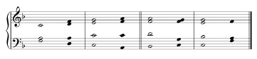
Song 1, Thomas Pavlechko (St. James Press)

1 I lift up my eyes to the hills; *
from where is my help to come?
2 My help comes from God, *
the maker of heaven and earth.
3 God will not let your foot be moved *
the One who watches over you will not fall asleep.
4 Behold, the One who keeps watch over Israel *
shall neither slumber nor sleep;
5 The Holy One watches over you; *
and is your shade at your right hand,
6 So that the sun shall not strike you by day, *
nor the moon by night.
7 God shall preserve you from all evil; *
and is the One who shall keep you safe.
8 God shall watch over your going out and your coming in, *
from this time forth for evermore.

Please stand, as able.
SEQUENCE HYMN VF 60 “Come and seek the ways of Wisdom” (Julion) verses 1, 3 On page 11

GOSPEL Luke 12:13-21

Gospeller The Holy Gospel of our Lord Jesus Christ according to Luke.
People Glory to you, Lord Christ.

Someone in the crowd said to him, ‘Teacher, tell my brother to divide the family inheritance with me.’ But he said to him, ‘Friend, who set me to be a judge or arbitrator over you?’ And he said to them, ‘Take care! Be on your guard against all kinds of greed; for one’s life does not consist in the abundance of possessions.’ Then he told them a parable: ‘The land of a rich man produced abundantly. And he thought to himself, “What should I do, for I have no place to store my crops?” Then he said, “I will do this: I will pull down my barns and build larger ones, and there I will store all my grain and my goods. And I will say to my soul, Soul, you have ample goods laid up for many years; relax, eat, drink, be merry.” But God said to him, “You fool! This very night your life is being demanded of you. And the things you have prepared, whose will they be?” So it is with those who store up treasures for themselves but are not rich towards God.’

Gospeller The Gospel of the Lord.
People Praise to you, Lord Christ.

THE SERMON Silence is kept after the sermon.

THE CREED Please stand, as you are able.
We believe in one God,
the Father, the Almighty, maker of heaven and earth, of all that is, seen and unseen.
We believe in one Lord, Jesus Christ, the only Son of God,
eternally begotten of the Father, God from God, Light from Light,
true God from true God, begotten, not made,
of one Being with the Father; through him all things were made.
For us and for our salvation he came down from heaven,
was incarnate of the Holy Spirit and the Virgin Mary and became truly human.
For our sake he was crucified under Pontius Pilate; he suffered death and was buried.
On the third day he rose again in accordance with the Scriptures;
he ascended into heaven and is seated at the right hand of the Father.
He will come again in glory to judge the living and the dead, and his kingdom will have no end.
We believe in the Holy Spirit, the Lord, the giver of life, who proceeds from the Father,
who with the Father and the Son is worshiped and glorified, who has spoken through the prophets.
We believe in one holy catholic and apostolic Church.
We acknowledge one baptism for the forgiveness of sins.
We look for the resurrection of the dead, and the life of the world to come. Amen.

A LITANY FOR CREATION AND ALL CREATURES
Deacon Let us name with thanksgiving those creatures for whom we care.
(We pause to name our thanksgivings, silently or aloud.)

Deacon Let us name with thanksgiving those creatures who have our companions over the years and are no longer with us.
(We pause to name our thanksgivings, silently or aloud.)

Deacon And let us remember the unnamed, unknown creatures whose lives have benefited our own.

Deacon Holy God, Creator of heaven and earth,
People Have mercy on us.

Deacon Holy and Mighty, Redeemer of the world,
People Have mercy on us.

Deacon Holy Immortal One, Sanctifier of the faithful,
People Have mercy on us.

Deacon Holy, blessed and glorious Trinity, One God,
People Have mercy on us.

Reader Grant that all your creatures may thank and serve you;
People Shower your blessing on earth, O God.

Reader Grant favorable weather, temperate rain, and fruitful seasons, providing food and drink for all your creatures;
People Shower your blessing on earth, O God.

Reader Open our eyes to the joy and beauty of creation, that we may see your presence in all your works;
People Shower your blessing on earth, O God.

Reader Look with favor upon all who care for the earth, the water, and the air, that the riches of creation may abound for all your creatures;
People Shower your blessing on earth, O God.

Reader Make us faithful stewards of creation, wisely caring for the earth, the air, the seas, and all the life they bear;
People Shower your blessing on earth, O God.

Reader Awaken us to our responsibility for the care of creation;
People Shower your blessing on earth, O God.

Reader Forgive us our waste and pollution of creation and strengthen us to heal wounds we have inflicted;
People Shower your blessing on earth, O God.

Reader Remember all in captivity and those who are hunted, trapped, deserted, or abused, that they
may find safety in homes of loving care;
People Shower your blessing on earth, O God.

Reader Do not forget those creatures who have died yet remain dear to us, that they may rejoice in
your new creation;
People Shower your blessing on earth, O God.

Presider Holy God: No sparrow falls without your attention; nothing dies that is lost to you; nothing comes into being without your love. Give us just and compassionate hearts, that we may serve the earth and all its creatures, holding fast to the vision of your peaceable reign in which all will live with you eternally; through the Risen One, Christ our Savior. Amen.

THE BLESSING OF THE ANIMALS
Please bring your pets or a photo of your pets to one of the stations, where the clergy will offer a blessing. We have stations located on the grass behind the main seating area as well as on the concrete patio.

THE PEACE We are encouraged to stand for the peace.
Presider The Peace of Christ be always with you.
People And also with you. We greet one another in the name of the Lord

ANNOUNCEMENTS
Please see the announcement insert. If you do not currently receive an email from us with current news and events, please contact info@churchofstmartin.org so we can be in touch. Feel free to take this bulletin and/or the announcements home with you.

CELEBRATIONS AND MILESTONES All may join in praying.
Watch over your children O Lord, as their days increase: bless and guide them wherever they may be. Strengthen them when they stand; comfort them when discouraged or sorrowful; raise them up if they fall; and in their hearts may your peace which passes all understanding abide all the days of their lives; through Jesus Christ our Lord. Amen.

OFFERTORY SENTENCE
Presider Walk in love, as Christ loved us and gave himself for us, an offering and sacrifice to God.

OFFERTORY NOTES The ushers will pass collection plates. Online giving is also available; just look for the blue “give” button on our website or the QR code near the back of this bulletin—or contact the office for more information. We are very grateful to those who have pledged and who give regularly, as well as for all plate offerings. Thank you!

OFFERTORY ANTHEM “Let the Whole Creation Cry,” Robert Leaf Sung by the Sanctuary Choir
Let the whole creation cry / “Glory to the Lord on high!”
Heav’n and earth awake and sing / “God is good, and therefore King!”
Praise him, all ye hosts above, / Ever bright and fair in love;
Sun and Moon uplift your voice, / Night and Stars, in God rejoice!
Men and women, young and old, / Raise the anthem manifold,
And let children’s happy hearts / In this worship bear their parts!
Praise him, all ye hosts above…

OFFERTORY RESPONSE (Franconia) Please stand and join in singing
We give thee but thine own, / Whate'er the gift may be;
All that we have is thine alone, / A trust, O God, from thee. —William Walsham Howe

THE GREAT THANKSGIVING
Presider The Creator be with you.
People And also with you.

Presider Lift up your hearts.
People We lift them to the Creator.

Presider Let us give thanks to our loving God.
People It is right to give God thanks and praise.

Presider
Praise and thanks are yours, our Creating God. From the dust of the earth you shaped human beings in your
own image, and you filled the earth and seas and skies with a myriad of wonders. Yet we consistently turn
your generosity into our scarcity, your elegance into our meanness, and your simplicity into our corruption.
Though we poison and destroy your good Creation, you continue to offer us your abundance. In your mercy,
you have redeemed us through your Son, Jesus, transforming death into life. Through the Spirit you continue
to call us into covenant with you—for the restoration of Creation and the reconciliation of all people. And so
we give you thanks, rejoicing with all of Creation, as we join the saints and angels in their unending hymn:

SANCTUS Presider and People S129 “Holy, holy, holy” (Powell) Presider and People
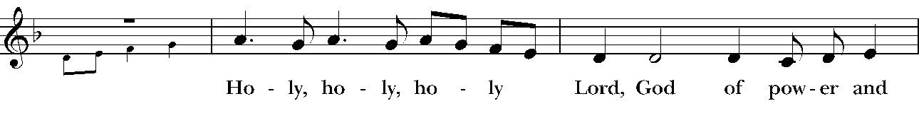
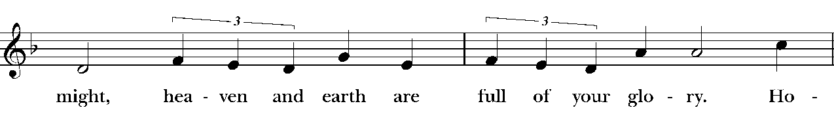
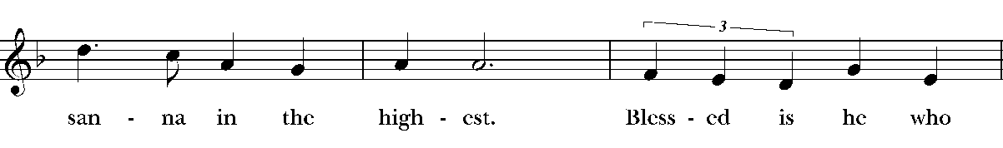
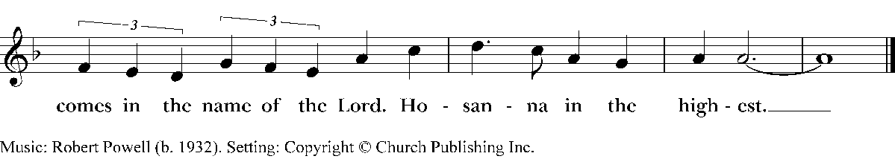

WORDS OF INSTITUTION The Presider continues Please kneel or stand, as you are able.
In the night that Jesus was betrayed, he took bread, and gave thanks to God. He broke the bread, gave it to his friends and said: “Take and eat, for this is my body, given for you. Do this in remembrance of me.” He took the wine, and gave thanks to God, Creator. He gave it to his friends saying: “This is my blood of the new covenant, shed for you and for all creation for the forgiveness of sins. Every time you drink of the wine, do this in remembrance of me.” So we proclaim the mystery of faith:

Christ has died. Christ is risen. Christ will come again.

Merciful God, we come to this table seeking reconciliation: with you, with one another, and with all creation. Through these mysteries reconcile us to our world and empower us to restore your Creation and fulfill your will. Send your life-giving Spirit upon us, and upon this bread and wine that it may be to us the Body and Blood of Christ Jesus. Stir in us the creative and redeem the destructive. Heal your stricken world, that the soil, the skies, and the seas may be filled with your life anew. Fill every heart with the sure and certain hope that we shall enter into the fullness of your joy, when your whole Creation is justified by faith and sanctified by love, and you are all in all. Through Christ and with Christ and in Christ, in the unity of the Spirit, all honor and glory is yours, everlasting God, now and forever. AMEN.

THE LORD’S PRAYER People and Presider
As our Savior Christ has taught us, we now say, (first in Spanish and then in English,)

Padre nuestro que estás en el cielo,  santificado sea tu Nombre,  venga tu reino,  hágase tu voluntad,  en la tierra como en el cielo.  Danos hoy nuestro pan de cada día.  Perdona nuestras ofensas,  como también nosotros perdonamos a los  que nos ofenden.  No nos dejes caer en tentación  y líbranos del mal.  Porque tuyo es el reino, tuyo es el poder,  y tuya es la gloria, ahora y por siempre.  Amén. | Our Father in heaven,  hallowed be your Name,  your kingdom come,  your will be done,  on earth as in heaven.  Give us today our daily bread.  Forgive us our sins  as we forgive those who sin against us.  Save us from the time of trial,  and deliver us from evil.  For the kingdom, the power,  and the glory are yours,  now and forever.  Amen.

THE BREAKING OF THE BREAD

THE FRACTION ANTHEM S 171 “Be known to us” (Plainsong/Martens)
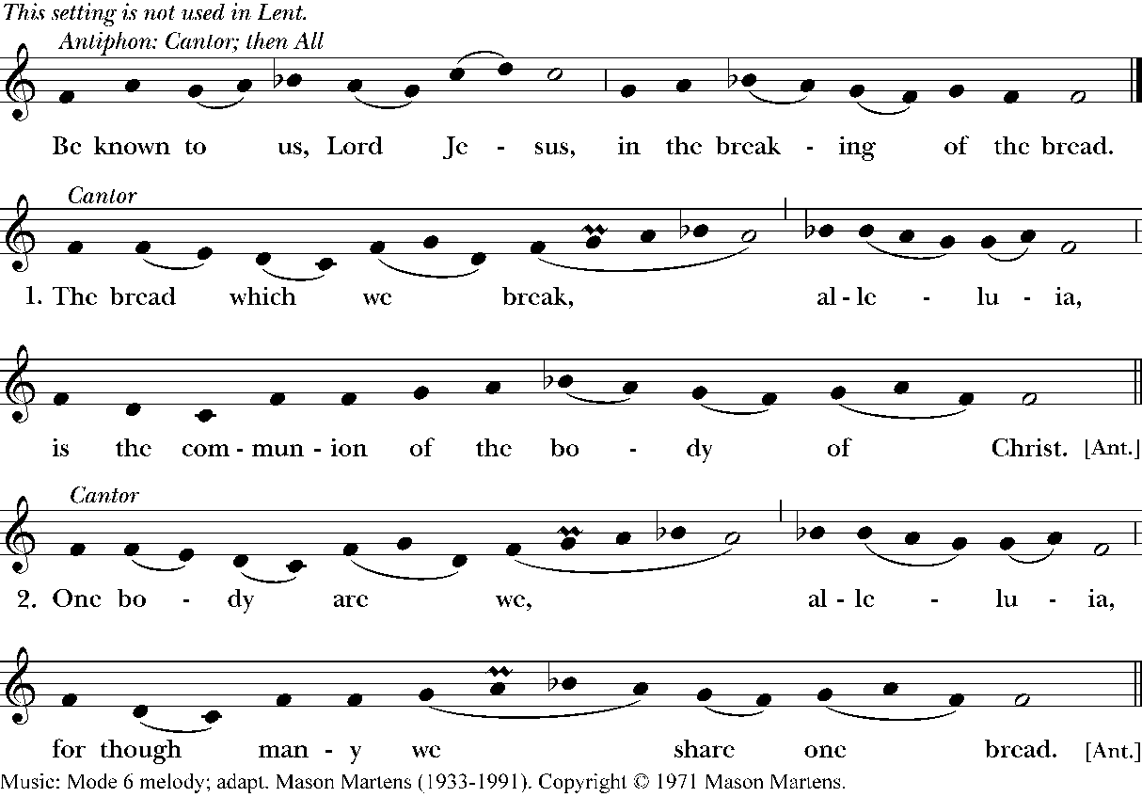

INVITATION AND DISTRIBUTION Presider
The Gifts of God for the People of God.

ABOUT RECEIVING HOLY COMMUNION All are welcome at God’s table, children included. The bread is gluten-free and vegan. Today, Communion will be in two stations. Go to the station on the left for intinction by the priest or the station on the right to drink from the common cup. The customary response upon receiving Communion is “Amen.” Crossing your arms over your chest indicates you would like a blessing instead of Communion.

COMMUNION MUSIC “We thank You, Lord of Heaven” (Shining Day) On page 12
H 431 “The stars declare his glory” (Aldine) On page 13

POST-COMMUNION PRAYER Please stand, as you are able.
Presider Let us pray.

Presider and People
Loving God, we give you thanks for restoring us in your image and nourishing us with spiritual food in the Sacrament of Christ’s Body and Blood. Now send us forth a people, forgiven, healed, renewed; that we may proclaim your love to the world and continue in the risen life of Christ our Savior. Amen.

BLESSING Presider
Go forth now to care for God’s world. Use resources wisely. Share your knowledge. Sacrifice where necessary. Live in harmony with all creation. Go out into all the world as prophets of a new way of
living and preach the good news to all. And the blessing of the Creator God, the Risen Son, and the Promised Holy Spirit bless you that you might be a blessing to others, today and always. Amen.

CLOSING HYMN H 405 “All things bright and beautiful” (Royal Oak) On page 14
DISMISSAL
Deacon Let us go forth into all Creation rejoicing in the power of the Spirit.
People Thanks be to God.

POSTLUDE “For the beauty of the earth” C. Kocher

Music Reprinted by Permission: One License A-715551; CCLI: 1839803; RiteSong © 2026 Church Publishing Inc. All rights reserved. Psalm text © Order of Saint Helena, used by permission. The Eucharistic Prayer and final blessing are from Season of Creation: A Celebration Guide for Episcopal Parishes (Perennial Edition, 2025).

Hymnal 400 “All creatures of our God and King” (Lasst uns freuen), v. 1, 4, 5, & 7

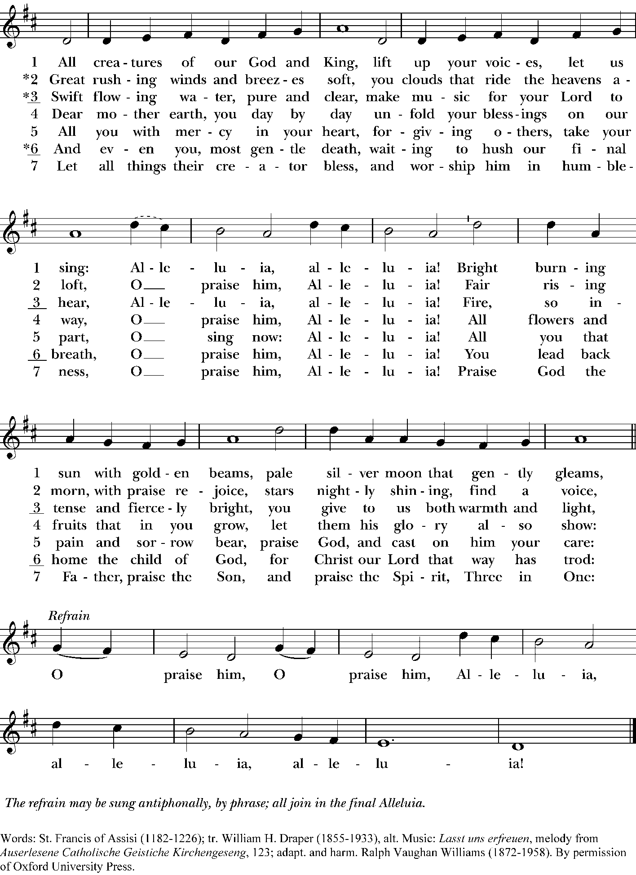

My Heart Sings Out 131 “We are a part of all creation,” M. Haugen

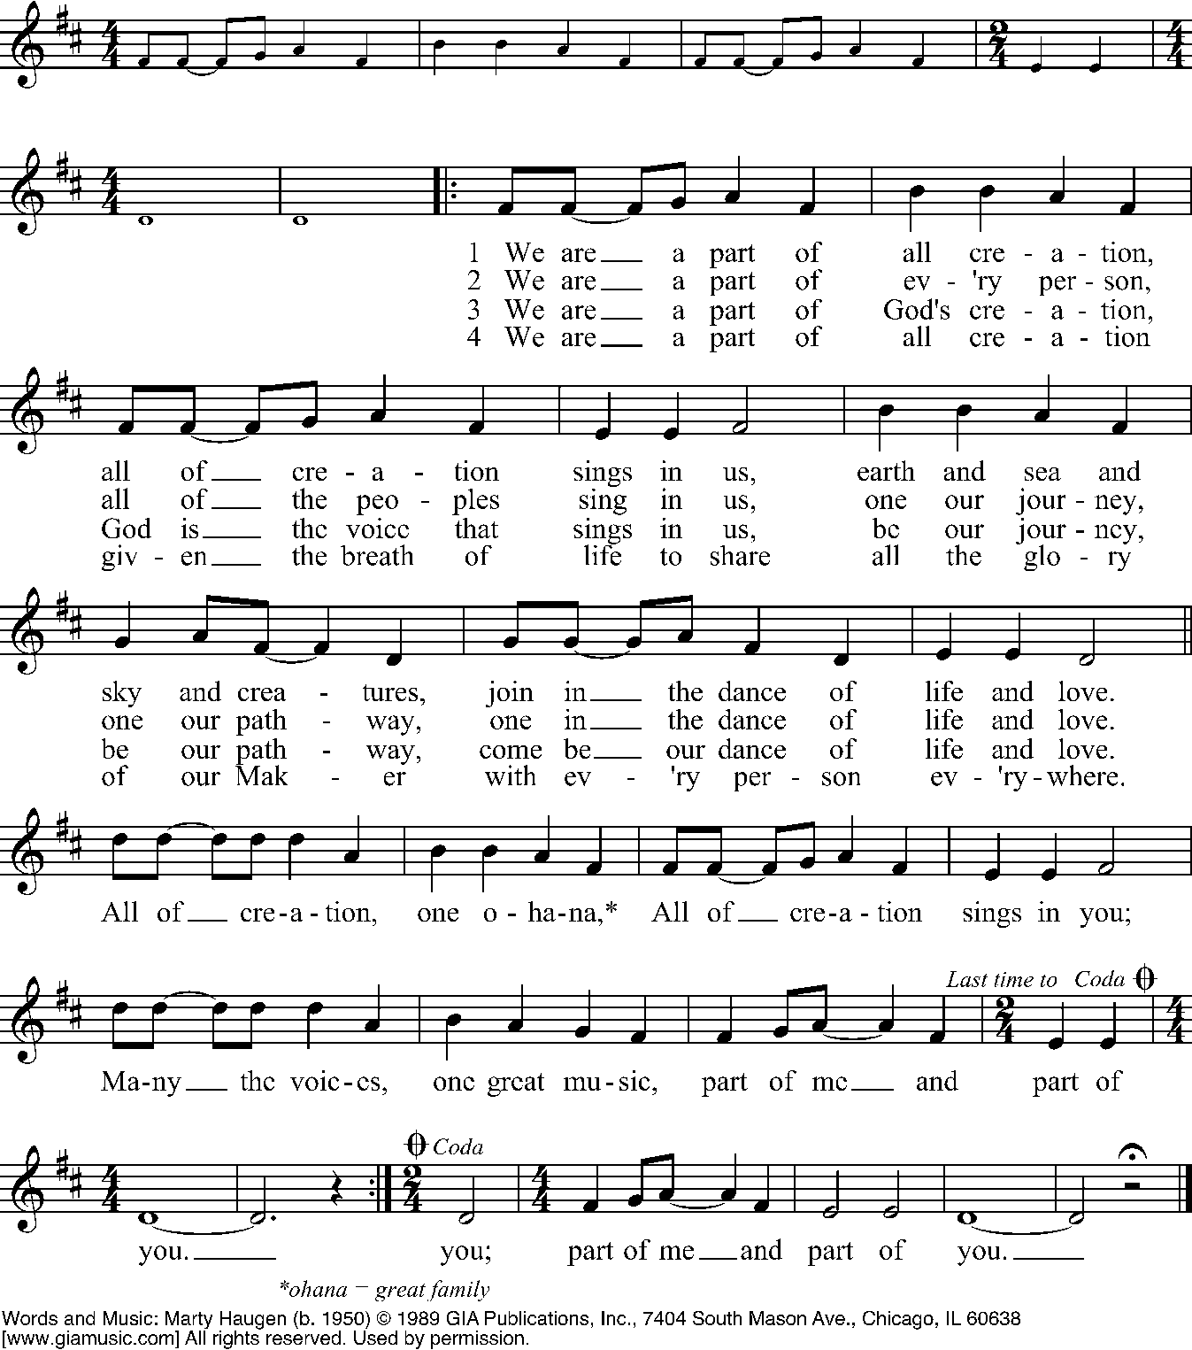

VF 60 “Come and seek the ways of Wisdom” (Julion) verses 1, 3
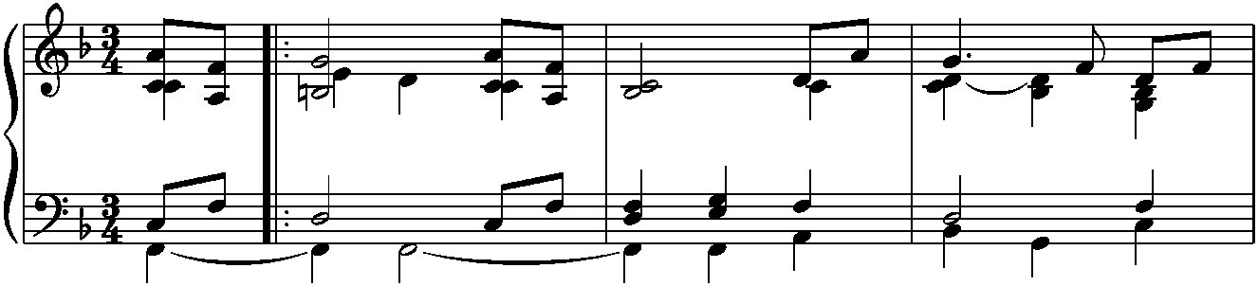
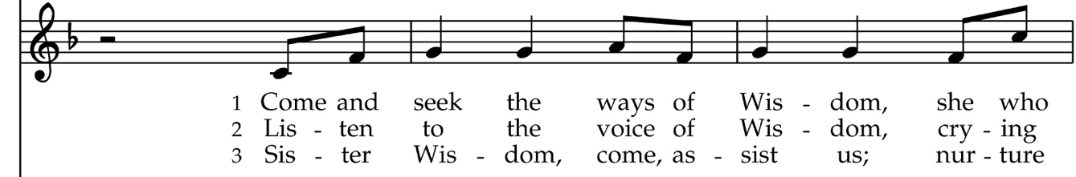
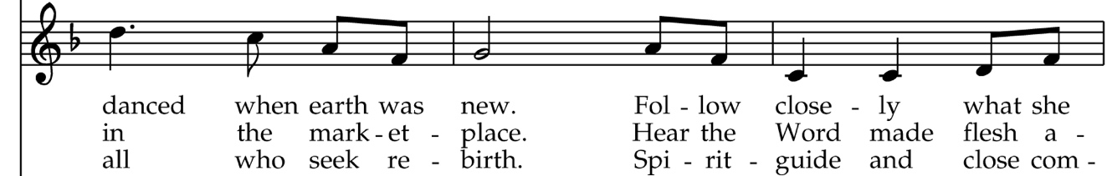
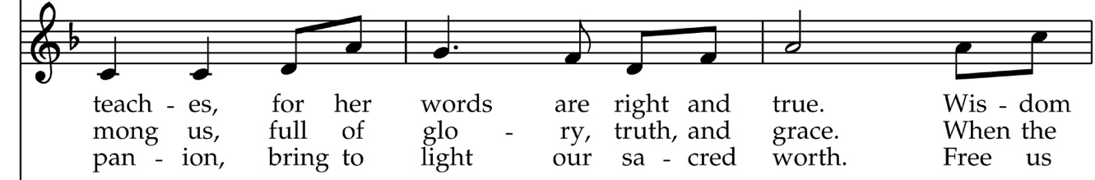
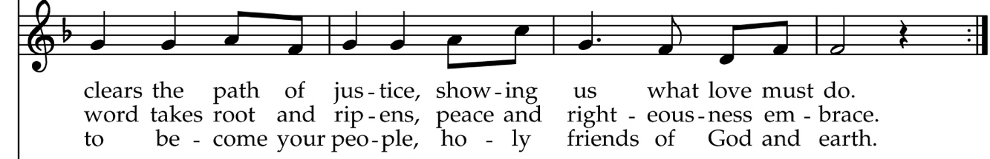

“We thank You, Lord of Heaven” (Shining Day), 1940 Hymnal #313
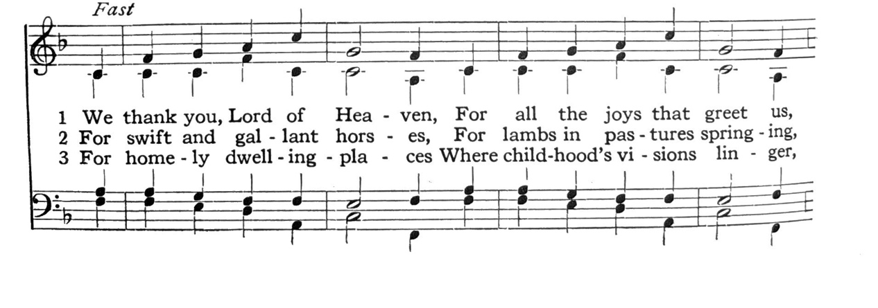
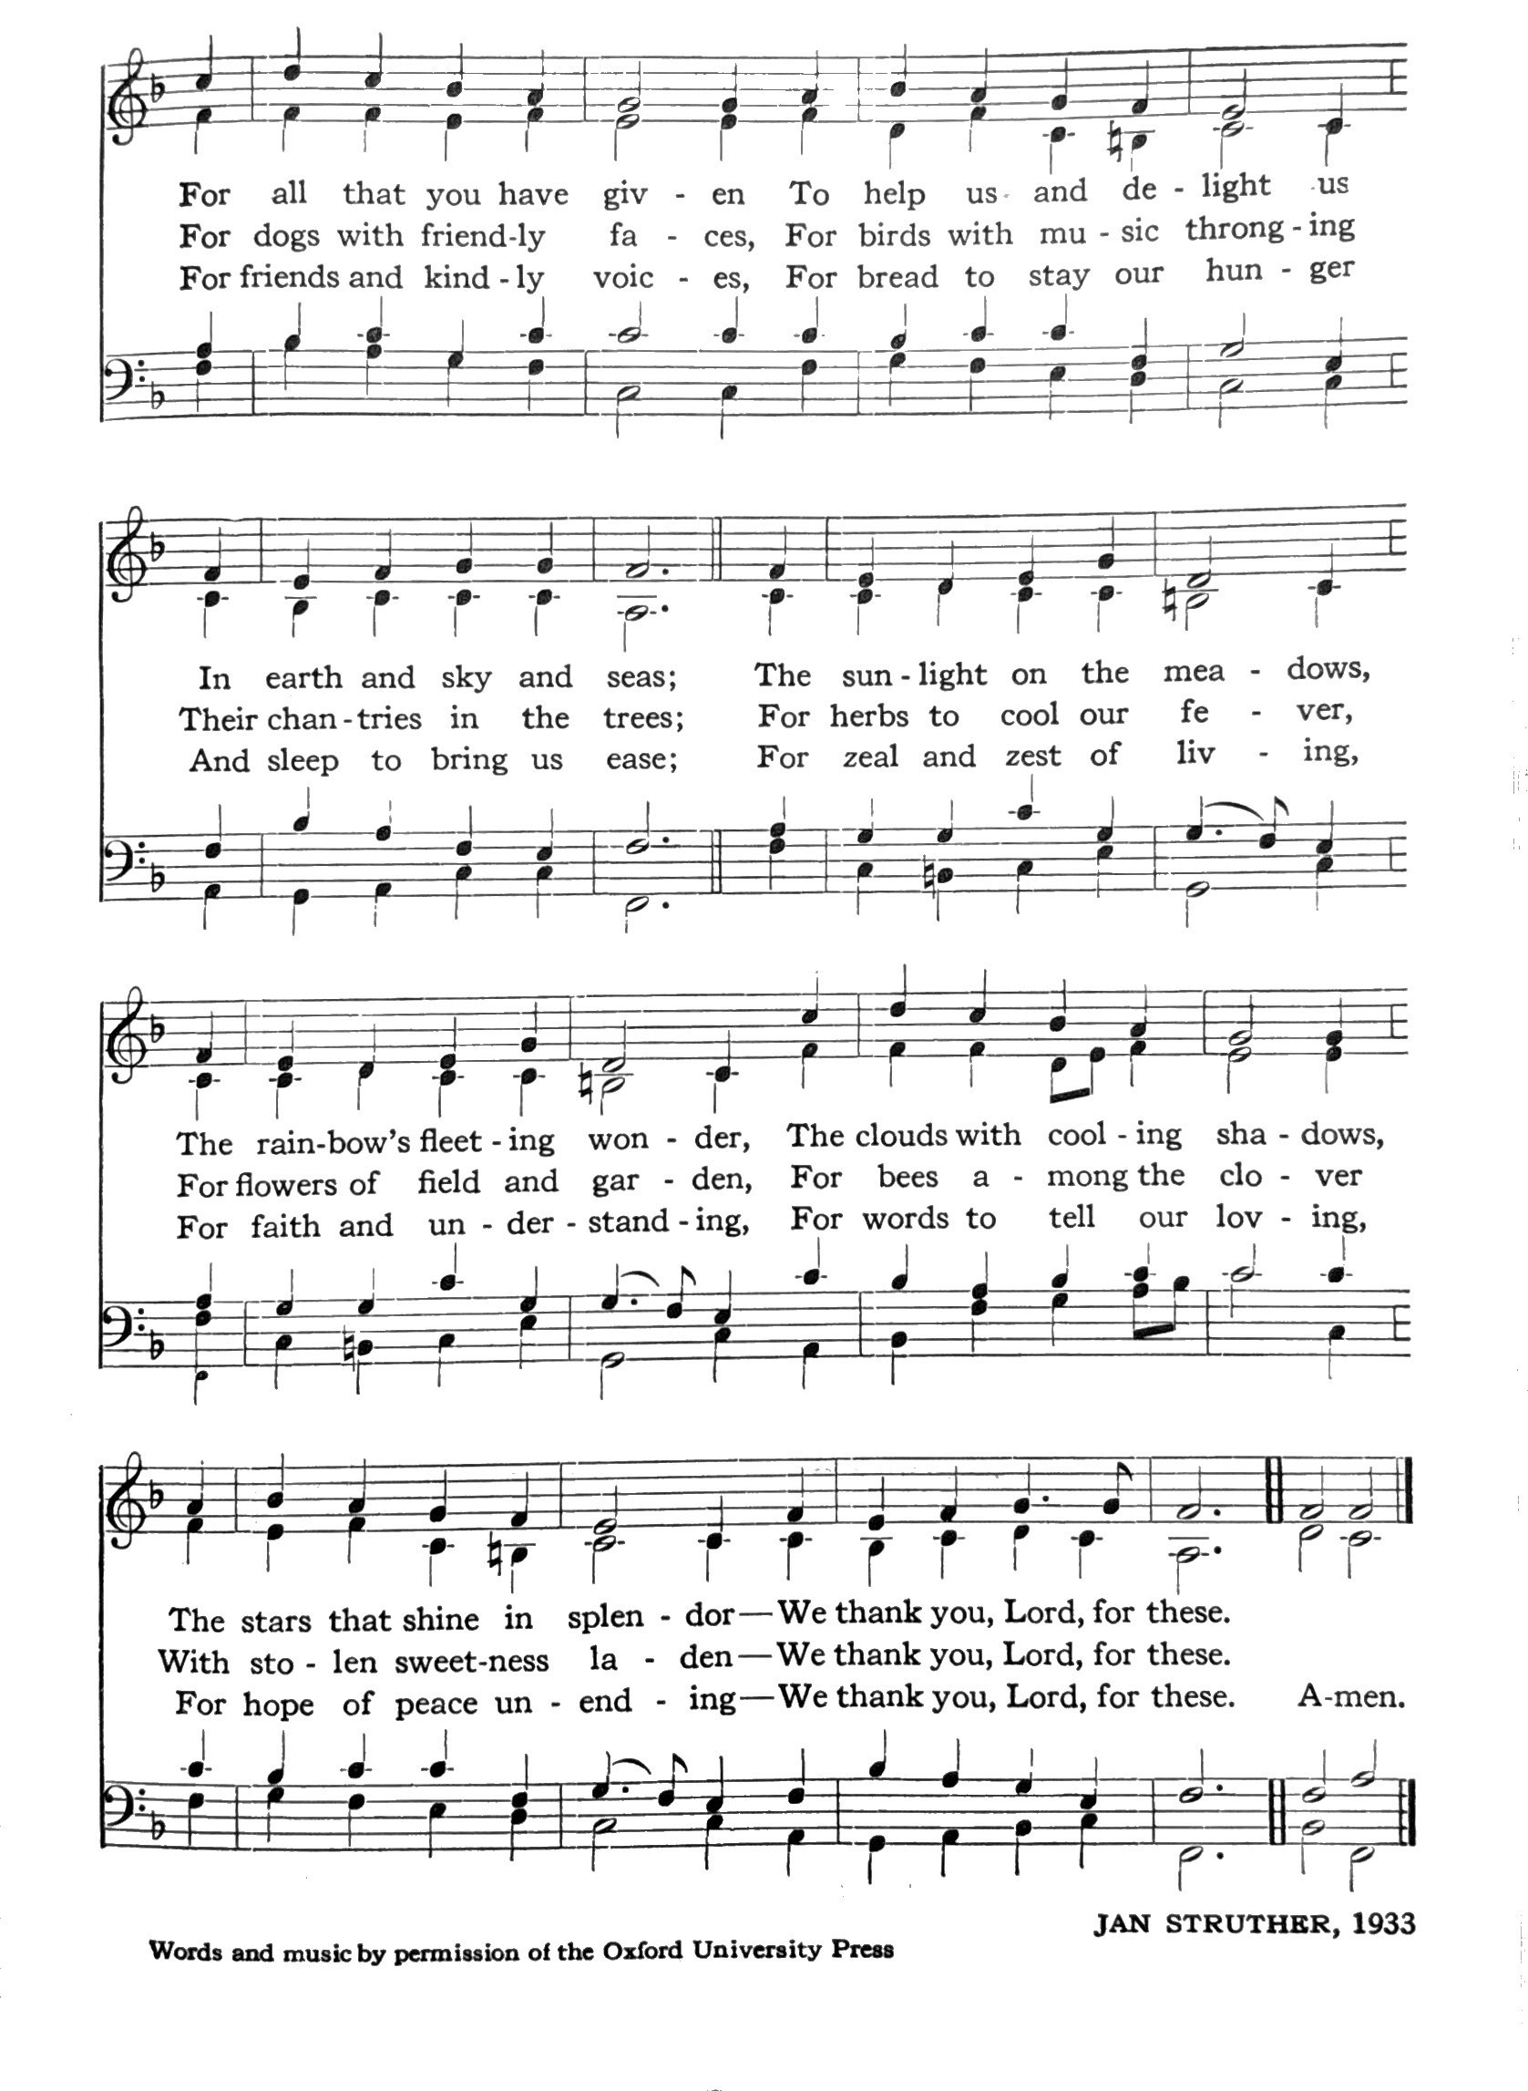
Hymnal 431 “The stars declare His glory” (Aldine)

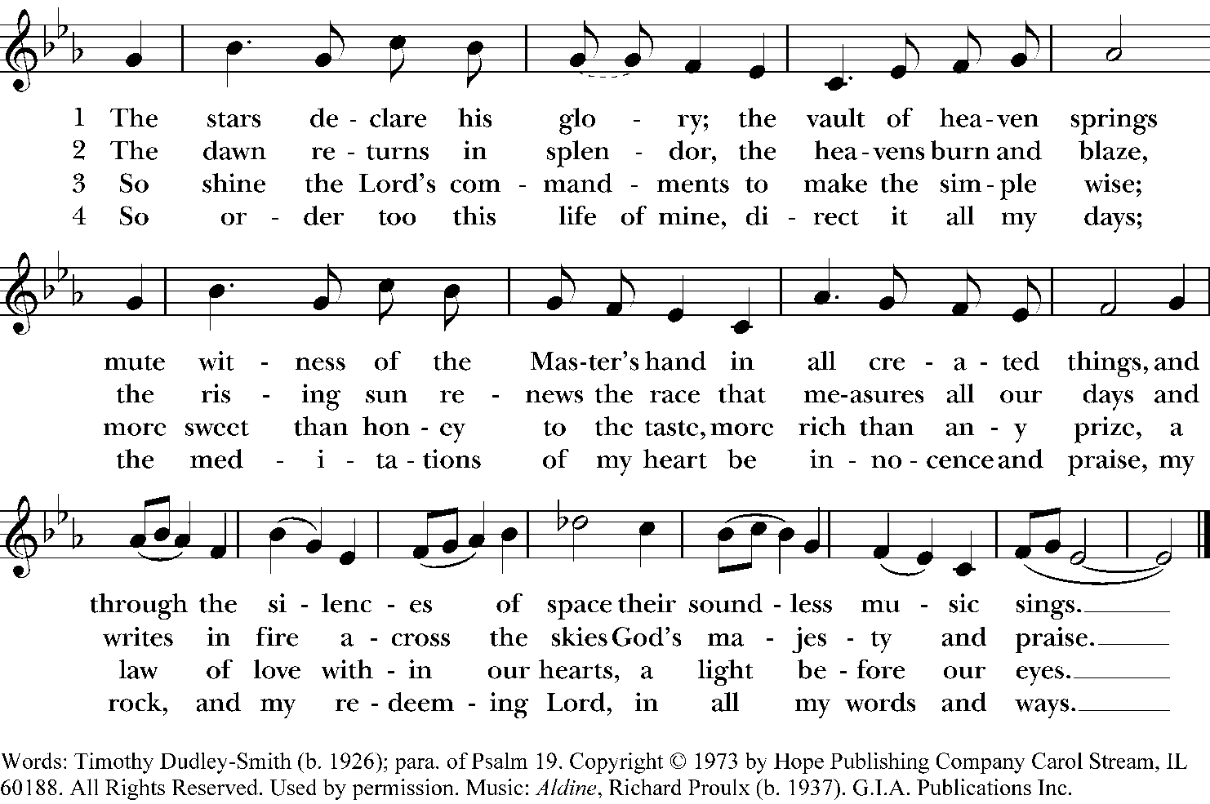

Hymnal 405 “All Things Bright and Beautiful” (Royal Oak)

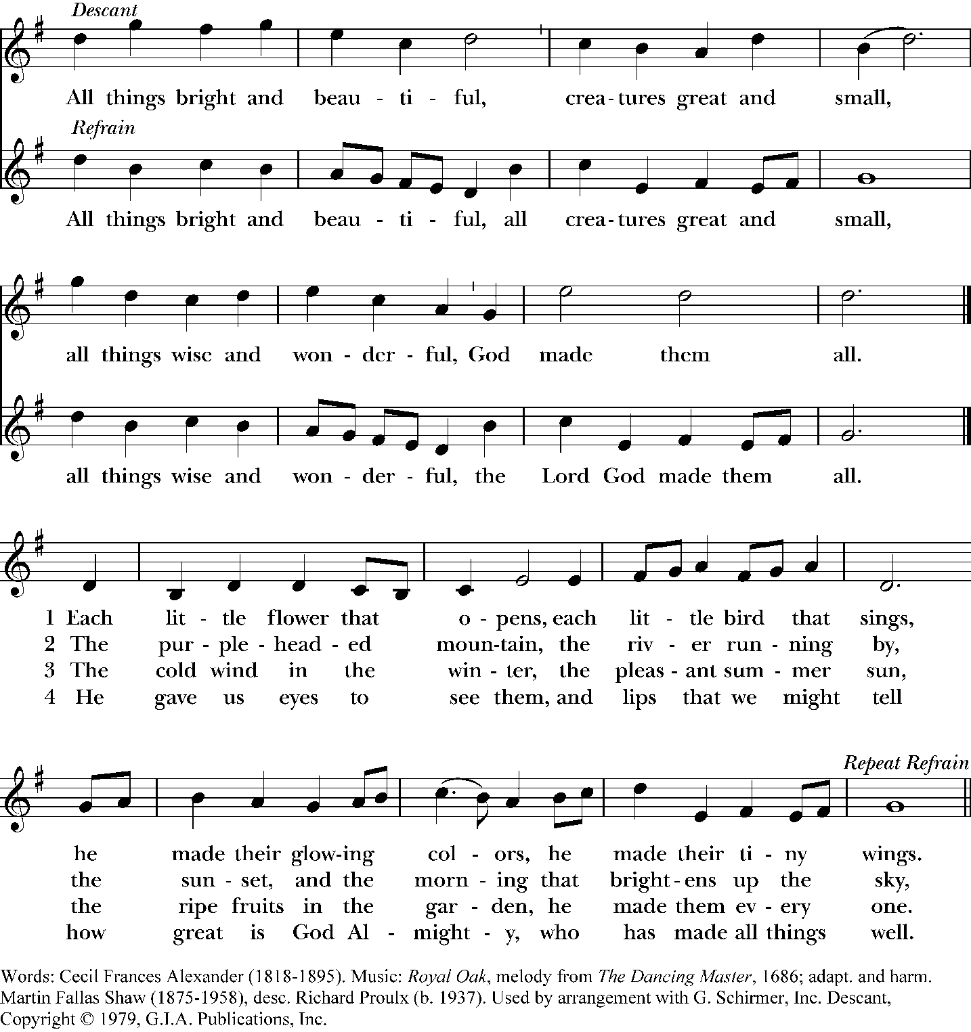

LITURGICAL MINISTERS
Presider and Preacher: The Very Rev. Dr. Pamela Dolan
Assisting Priests: The Rev. Ernie Lewis, The Rev. Deborah Hawkins
Deacons: The Rev. Maggie Rutherford, The Ven. Margaret Grayden
Music Ministers: Jeffrey Jubenville, Dr. Suzanne Jubenville
Readers: John Dolan, Josie Avila
Eucharistic Minister: Janet Lane
Ushers: Tim Williams, Michael Stary, Garda Johnson
Altar Guild: Carla Harris, Dorothy Brandon, Margaret Hill
Flowers: Kristin McMillin

LAND ACKNOWLEDGMENT
We acknowledge the land on which we are gathered. For thousands of years, this land has been the home of Patwin people. Today, there are three federally recognized Patwin tribes: Cachil Dehe Band of Wintun Indians of the Colusa Indian Community, Kletsel Dehe Wintun Nation, and Yocha Dehe Wintun Nation. The Patwin people have remained committed to the stewardship of this land over many centuries. It has been cherished and protected, as elders have instructed the young through generations. We are honored and grateful to be here today on their traditional lands.

CHURCH CONTACT INFORMATION
Rector: The Very Rev. Dr. Pamela Dolan, pamela@churchofstmartin.org
Associate: The Rev. Ernest L. Lewis, ernie@churchofstmartin.org
Associate: The Rev. Deborah Hawkins, debbie@churchofstmartin.org
Associate: The Rev. Randall V. Demary, randy@churchofstmartin.org
Deacon: The Ven. Margaret Grayden, margaret@churchofstmartin.org
Deacon: The Rev. Maggie Rutherford, maggie@churchofstmartin.org
Music Ministers: Jeffrey and Dr. Suzanne Jubenville, jubenvilles@churchofstmartin.org
Church Operations Director: Gabe Avila, communications@churchofstmartin.org
Administrative Assistant: Janet Lane, info@churchofstmartin.org
Treasurer: Jessie Ann Owens, treasurer@churchofstmartin.org

VESTRY (vestry@churchofstmartin.org) Maria Acuna-Feldman (Sr. Warden), Mae Barnes, Stan Forbes, Kevin Hanks, Carole Hom, Jim Jordan, Elise Keddie (Jr. Warden), Anthony Miller, Stephen Reynolds.



The Episcopal Church of St. Martin • 640 Hawthorn Lane • Davis, California • 95616
(530) 756-0444 • info@churchofstmartin.org • www.churchofstmartin.org
We are a carbon neutral church.

